**Feasibility Memo Table**

You and your team have been assigned by the Thermo Fisher Scientific Company to write a opening-summary feasibility memo, detailing your recommendation for the best travel plans for one of its sales people. It was decided at your last staff meeting that your company Thermo Fisher Scientific, will send one representative by the name Jane Williams to a national convention in Las Vegas, Nevada. This convention runs from 9:00 am Thursday January 12, 2017 to 5:00pm Sunday January 15, 2016. It will take place at Plaza Hotel and Casino. You can assume the convention center provides a free shuttle to and from the airport, and that the convention center is no more than 45 minutes from the airport.

Your company has a policy that there must be eight hours of time between the landing of the plane and the employees next scheduled shift. They are willing to send one representative as they have in the past seven years, but they are concerned that the times and costs are reasonable.

In order to produce this memo, you will need to research competing travel arrangements and present the findings in a stand-alone comparison table. This comparison table should be detailed enough that it can stand apart from the final memo even though it will be added to the body of that memo.

8am Tues earliest flight in

8pm Sunday earliest flight out

Convention cost

Entrance to the convention

What Food?

Hotel – Food?

What airport

Parking

Rental car?

Orbitz - pick two different airlines

Hotels – Downtown Las Vegas

Leaving Work Early

Arriving to work late

FLIGHT Option 1 DELTA

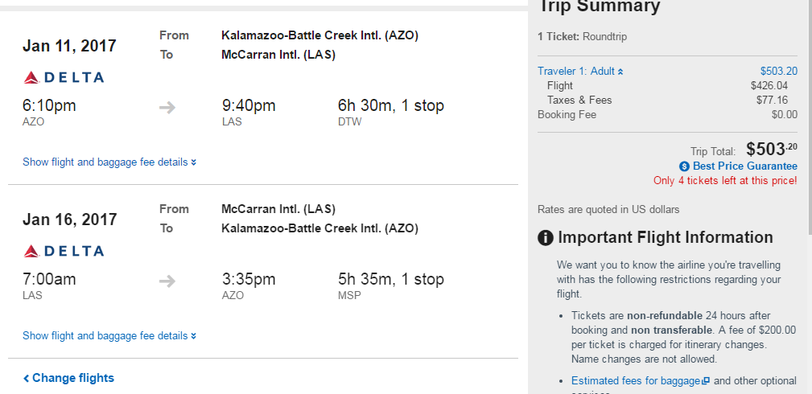

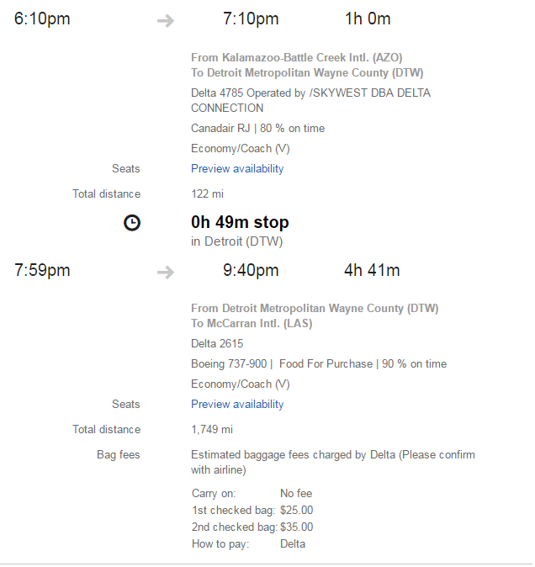

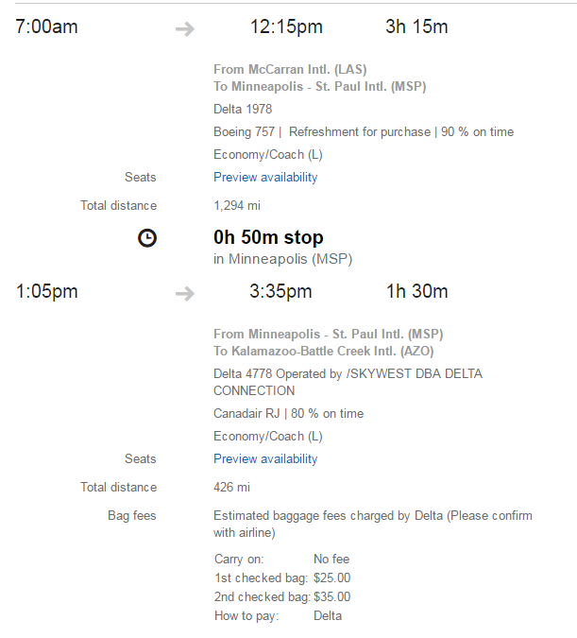

Flight 2 Option – American Airlines

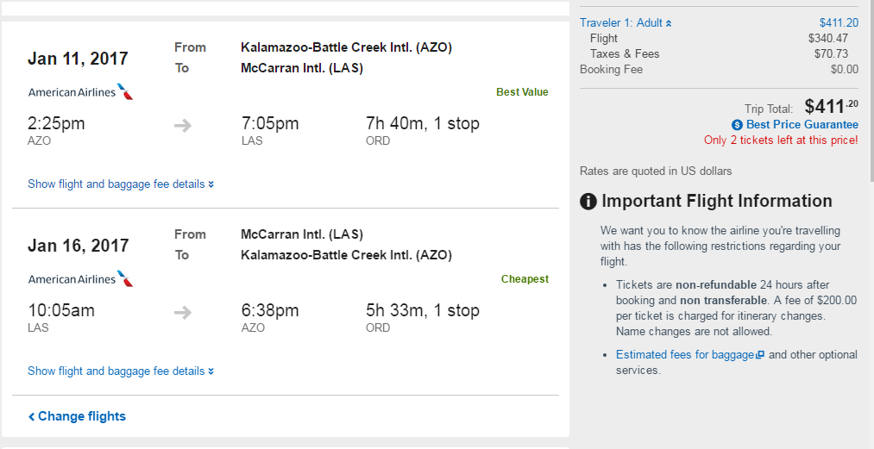

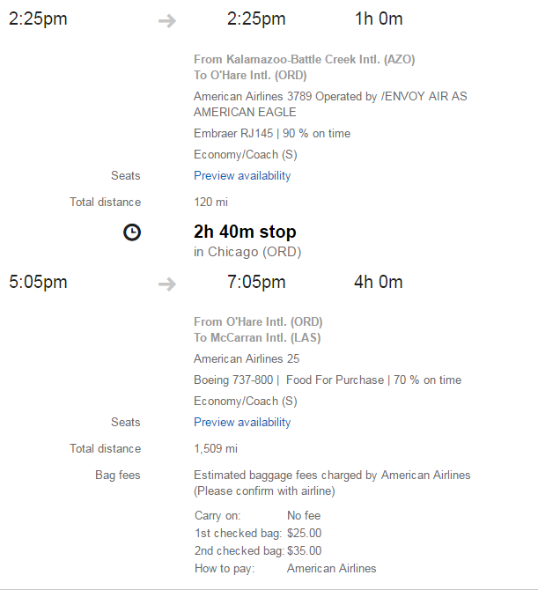

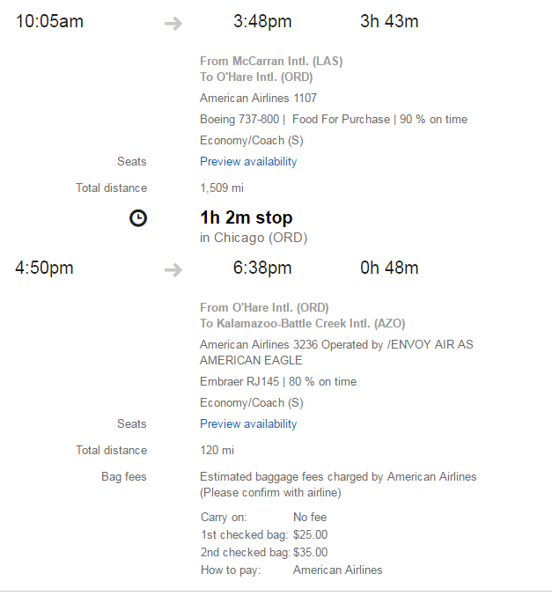

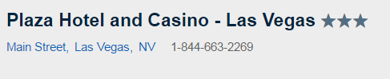

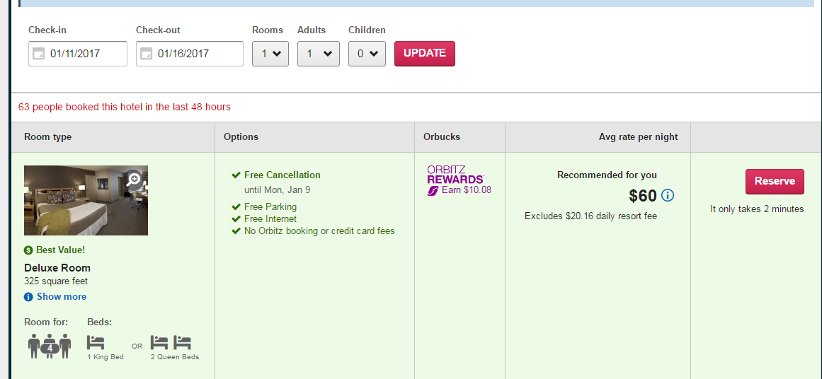

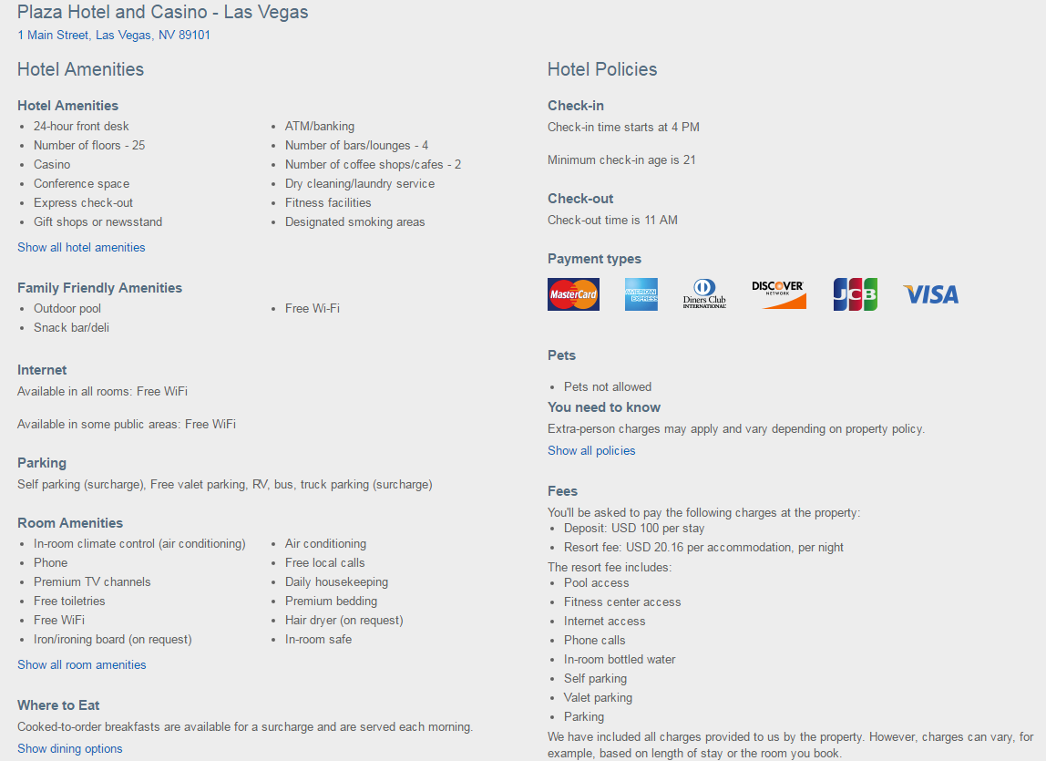

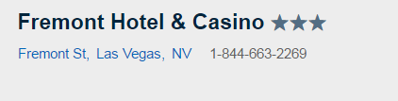

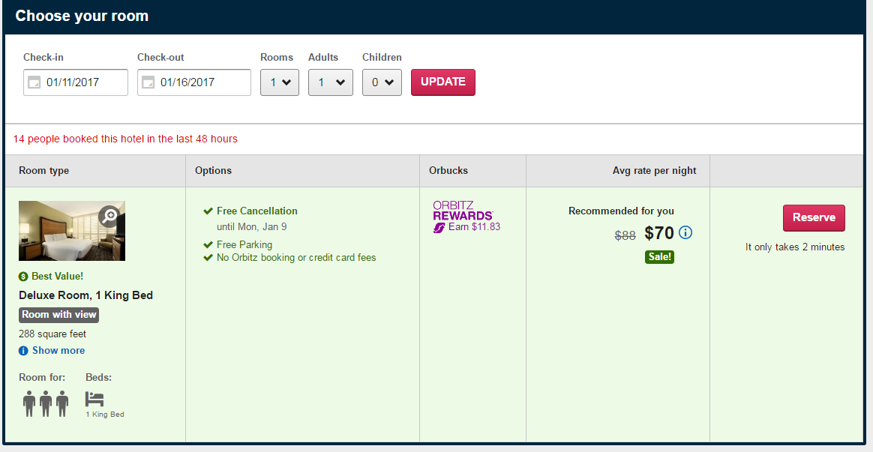

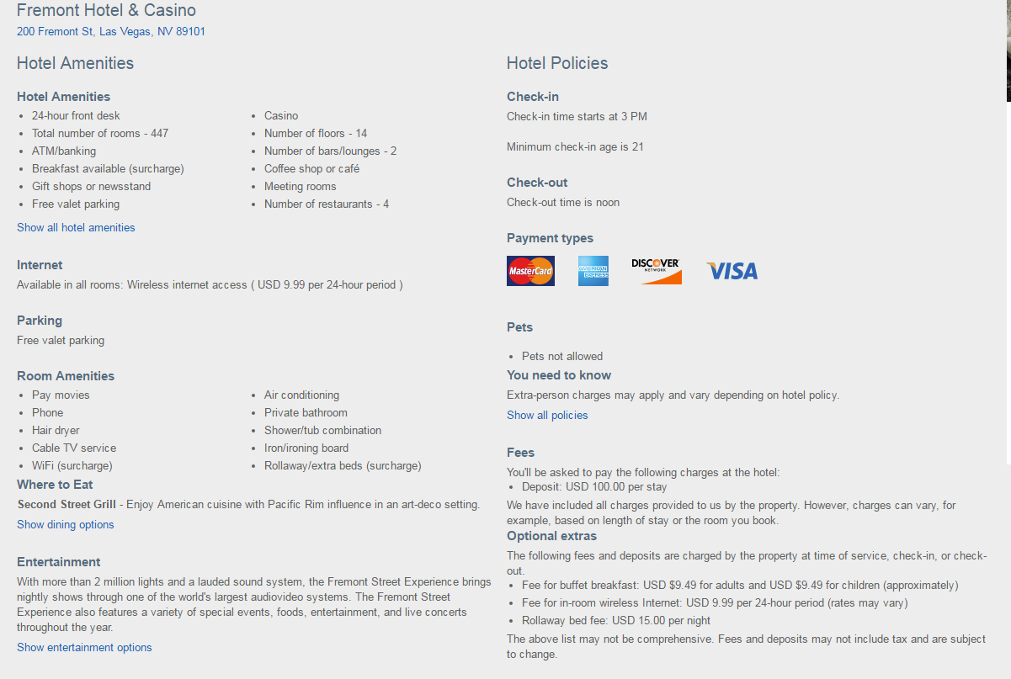

Samples

7.1 A numeric table

7.2 A textual table

Before making the table, answer the following questions.

1. What information will the department manager need from this table? Exactly what the differences in the options will be and the cost How will he/she use this information?To determine the which option is better.
2. What information with the representative who is being sent to the convention need? Times of events and what arrangements have been made. How will he/she use this information? To determine when and how she will travel, eat, and perform her job at the convention.
3. What information will payroll/accounting need from this table? The cost of each item and when the representative will need off. How will they use this information? To pay for time off and the expenses of the convention.
4. What column headings will you need? Option I Fling Delta and Option 2 Flying American What title can you give this that will give the main idea of the table? Travel plans for the AITP National Collegiate Convention and Career Fair.
5. Do you need row labels? Yes If so, what ones will you use? Travel, Accommodations, Food, and Convention

After making the table, answer the following questions.

1. Explain why you think this table is effective. It clearly demonstrates the two options and communicates everything the Manager and Representative needs to know. Consider the yellow box on p. 116.
2. What ethical considerations (p. 69) were involved in making this table? Being truthful and factual and consider how the plans would impact both the company and employee.
3. How do you see this table interacting with the feasibility memo? It should go along with the memo demonstrating each paragraph with factual information.

Hand-in

* 1. Final draft of the table

2. Response questions

3. Scoring sheet

**Feasibility Memo Table**

Evaluation

4 requirements are met, and the work is ready to use as is

3 requirements are met; the work is usable, but could be improved

2 most requirements are met, and the work has the potential to be used after modification and/or revision

1 some requirements are met, but many modifications and/or much revision is needed to make this work usable

0 requirements are not met

Unity

* Main idea is stated directly in the title
* The work as a whole is focused and free from irrelevant detail.

Coherence

* Table is logically organized
* Titles identify the columns and if necessary rows
* Each cell of the table is easy to understand

Support

* Information is complete and accurate.
* Context of the table is explained in the caption
* Sources are informally documented in the caption

Style

* Wording and phrasing are simple and direct.
* Formatting is consistent and meets readers’ expectations.
* Content is written in parallel form
* Fonts and white space are used well.

Grammar and Sentence Structure

* Conventional grammar, spelling, and punctuation are used.
* Sentences are varied and reflect the proper use of pronouns, modifiers, subject-verb agreement, and tenses.
* Run-on and fragmented sentences are eliminated.